

EADN Signing –

A Guide for Developers

Valid as from version 2.3

Status: 06 / 2013

EPLAN Software & Service GmbH & Co. KG  
Technical information

Copyright © 2013 EPLAN Software & Service GmbH & Co. KG

EPLAN Software & Service GmbH & Co. KG assumes no liability for either technical or printing errors, or for deficiencies in this technical information and cannot be held liable for damages that may result directly or indirectly from the delivery, performance, and use of this material.

This document contains legally protected proprietary information that is subject to copyright. All rights are protected. This document or parts of this document may not be copied or reproduced by any other means without the prior consent of EPLAN Software & Service GmbH & Co. KG.

The software described in this document is subject to a license agreement. The use and reproduction of the software is only permitted within the framework of this agreement.

RITTAL® is a registered trademark of Rittal GmbH & Co. KG.

EPLAN®, EPLAN Electric P8®, EPLAN Fluid®, EPLAN PPE®, EPLAN Cabinet®, EPLAN Pro Panel®, EPLAN Mechatronic Integration® and EPLAN Harness proD® are registered trademarks of EPLAN Software & Service GmbH & Co. KG.

Windows 7®, Windows 8®, Windows Server 2012®, Microsoft Windows®, Microsoft® Excel®,   
Microsoft® Access® and Notepad® are registered trademarks of the Microsoft Corporation.

PC WORX®, CLIP PROJECT®, and INTERBUS® are registered trademarks of Phoenix Contact GmbH & Co.

AutoCAD® and AutoCAD Inventor® are registered trademarks of Autodesk, Inc.

STEP 7®, SIMATIC® and SIMATIC HW Konfig.® are registered trademarks of Siemens AG.

InstallShield® is a registered trademark of InstallShield, Inc.

Adobe® Reader® and Adobe® Acrobat® are registered trademarks of Adobe Systems Inc.

TwinCAT® is a registered trademark of Beckhoff Automation GmbH.

Unity Pro® is a registered trademark of Schneider Electric.

RSLogix 5000® and RSLogix Architect® are registered trademarks of Rockwell Automation.

All other product and trade names and company names are trademarks or registered trademarks of their respective owners.

EPLAN uses the Open Source software 7-Zip (7za.dll), Copyright © by Igor Pavlov. The source code of 7-Zip is subject to the GNU Lesser General Public License (LGPL). The source code of 7-Zip as well as details on this license are available on the following Internet page: http://www.7-zip.org

EPLAN uses the Open-Source-Software Open CASCADE, Copyright © by Open CASCADE S.A.S. The source code of Open CASCADE are subject to the Open CASCADE Technology Public License. For the Open CASCADE source code and more details about this license, go to: http://www.opencascade.org

Table of contents

[Introduction 4](#_Toc358288704)

[Notes for the Reader 4](#_Toc358288705)

[Concept of EADN signing 6](#_Toc358288706)

[Requirements 6](#_Toc358288707)

[How you proceed 6](#_Toc358288708)

[Modify the AssemblyInfo 6](#_Toc358288709)

[Delay sign the Assemblies 7](#_Toc358288710)

[Zip and Upload to EPLAN File Exchange 7](#_Toc358288711)

[Receive the signed Assemblies 9](#_Toc358288712)

[Special Cases 10](#_Toc358288713)

[How to sign automatically generated serialization dlls 10](#_Toc358288714)

[Signing of your own COM interop dlls 10](#_Toc358288715)

Introduction

Dear customer,

As a part of your EADN (EPLAN API Developer Network) partnership with EPLAN Software & Service you get the opportunity to sign your software interface with our products. This allows your customer to access to our products through your software, without having a license for the EPLAN API module on his workstations. Instead, he receives – through you – a runtime license for your interface.

This document describes how you or your developers proceed, to get properly signed EADN modules.

Notes for the Reader

Before you begin reading, please note the following symbols and styles used in this document:

warningWarning:

Text preceded by this symbol contains a warning; you should be absolutely sure to read this warning before proceeding!!

T:\W3\Nachtlauf_Flare\V_1_9_D\de_DE\EPLAN_Global\Content\Pictures\Gui\ALL\note.gifNote:

Text preceded by this symbol contains extra notes.

T:\W3\Nachtlauf_Flare\V_1_9_D\de_DE\EPLAN_Global\Content\Pictures\Gui\ALL\info.gifTip:

Useful tips to facilitate your interaction with the program are presented after this image.

T:\W3\Nachtlauf_Flare\V_1_9_D\de_DE\EPLAN_Global\Content\Pictures\Gui\ALL\example.gifExample:

Examples are highlighted by this symbol.

* User interface elements are marked in bold so they can immediately be located in the text.
* Italic text provides particularly important information that you should definitely pay attention to.
* Code examples, directory names and direct entries (among other things) are displayed in a non-proportional font.
* Function keys, keyboard keys, and buttons within the program are shown in square brackets (e.g., [F1] for the "F1" function key).
* To improve the flow of the text, we often use "menu paths" in this document (for example, Help > Contents). In order to find a particular program function, the menus and options shown in a menu path must be selected in the sequence shown. For example, the menu path mentioned above calls up the EPLAN help system.
* The operating information provides step-by-step instructions for reaching specific targets, and in many places, after the right-arrow symbol T:\W3\Nachtlauf_Flare\V_1_9_D\de_DE\EPLAN_Global\Content\Pictures\Gui\ALL\arrow.gif you'll also find the program's reaction to your action.
* In combination with settings or fields (e.g., check boxes) which can only be switched on or off, in this document we often use the term "activate" (after which the setting is active T:\W3\Nachtlauf_Flare\V_1_9_D\de_DE\EPLAN_Global\Content\Pictures\Gui\ALL\all_checkon_as.gif) and "deactivate" (after which the setting is inactive T:\W3\Nachtlauf_Flare\V_1_9_D\de_DE\EPLAN_Global\Content\Pictures\Gui\ALL\all_checkoff_as.gif)

Concept of EADN signing

EADN uses a concept of combining standard .Net strong naming with additionally including an EPLAN license option to the software. To achieve this combination, please follow the instructions in this document.

Requirements

After you have concluded your EADN contract und announced creating a new software interface with EPLAN, you will receive from us the login data of your account for the EPLAN file exchange web site and a file containing the public part of a standard signature key, normally used for strong-naming a .Net assembly. We created this key especially for your software.

How you proceed

Take the following steps to get your application EADN-signed:

Modify the AssemblyInfo

In your software projects, you need to add an additional attribute to your AssemblyInfo files of all the assemblies, which are referencing EPLAN API Assemblies. The EplanSignedAssemblyAttribute is implemented in the Eplan.EplApi.Starter.dll, which you always have to reference in your API application. The following example shows how to use the attribute in your AssemblyInfo file:

T:\W3\Nachtlauf_Flare\V_1_9_D\de_DE\EPLAN_Global\Content\Pictures\Gui\ALL\example.gifExample:

using System.Reflection;

using System.Runtime.CompilerServices;

using System.Runtime.InteropServices;

using Eplan.EplApi.Starter;

//…

[assembly: EplanSignedAssemblyAttribute(true)]

Delay sign the Assemblies

The easiest way for delay signing your assemblies (dll or exe) is entering the public key file in the signing properties of your software projects in Visual Studio. Check "Sign the assembly" and activate the "Delay sign only" flag. See the following image:

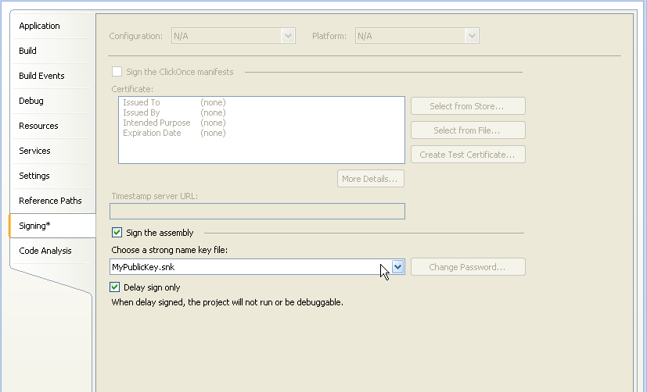

The delay signing is done, when building the software project and with it creating the assembly.

Alternatively, you can use Microsoft"s Assembly Linker "Al.exe" to manually delay sign assemblies. Please refer to respective MSDN documentation.

Zip and Upload to EPLAN File Exchange

Create one or several ZIP archives containing all the assemblies to be signed. Please take into account that the zip files may not be password-protected.

Log in to the EPLAN file exchange portal at <https://service.eplan.de/exchange> with the login data mentioned above.

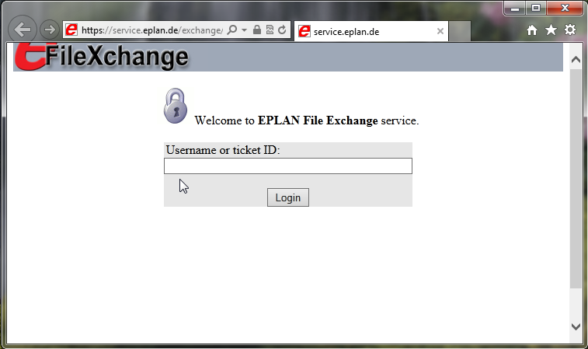

Select the software project for which the assemblies should be signed. The project has to be the same as the one for which you received and used the respective public key.

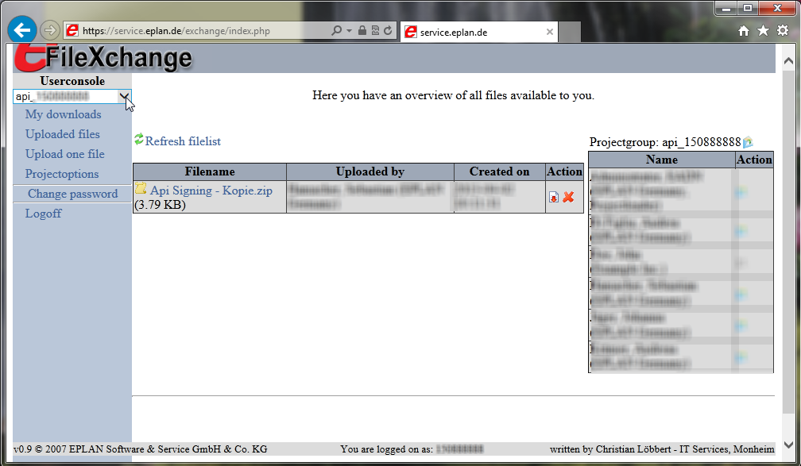

Now upload the zip file to our server by clicking "Upload one file", selecting the zip file and clicking "Upload". This triggers the signing process.

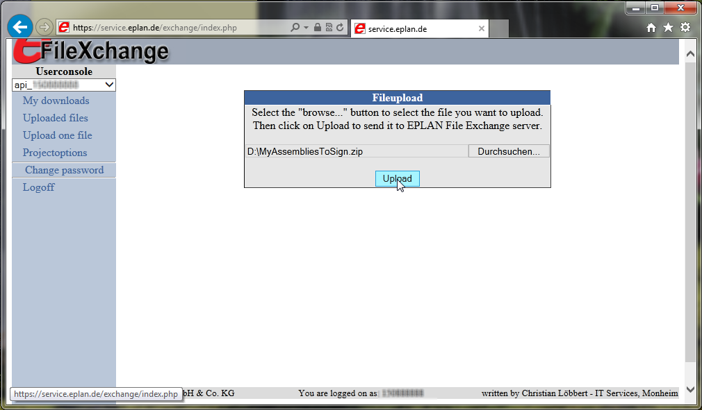

Receive the signed Assemblies

As soon as your files have been signed you will receive an email that you can download the ready-signed files again from our file exchange portal. Log in again and find your files under "My downloads". The ZIP file contains an additional log file with a message, whether the signing was successful or not. In case the signing procedure failed, the log file will contain further information about the problem.

Special Cases

How to sign automatically generated serialization dlls

If you use an automatically created serialization dll for your classes, you need to delay-sign them via the sgen.exe tool. This tool can be found the SDK directory of your development environment.

T:\W3\Nachtlauf_Flare\V_1_9_D\de_DE\EPLAN_Global\Content\Pictures\Gui\ALL\example.gifExample:

"C:\Program Files\Microsoft Visual Studio 8\SDK\v2.0\bin\sgen.exe" /compiler:/delaysign+ /assembly:"MyDllToBeSerialized.dll" /proxytypes  
 /reference:"Eplan.EplApi.AFu.dll" /reference:<…all further references you need> /compiler:/keyfile:"D:\MyPublicKey.snk"

Signing of your own COM interop dlls

As you probably know, any strong-named .Net assembly can only reference / load other strong-named assemblies. In case your application registers COM dlls, the development environment normally automatically creates so-called interop dlls, which contain the .Net wrapping of the respective COM methods. Normally, these dlls are not signed. To create these assemblies in an already delay-signed way Microsoft provides the command line tool tlbimp.exe – also to be found in the SDK directory of your development environment. See the following example, how it is used:

T:\W3\Nachtlauf_Flare\V_1_9_D\de_DE\EPLAN_Global\Content\Pictures\Gui\ALL\example.gifExample:

"C:\Program Files\Microsoft Visual Studio 8\SDK\v2.0\Bin\tlbimp.exe" yourComInterface.dll /delaysign /publickey:C:\YourKeyFilePublic.snk /out:Interop.yourComInterface.dll

|  |  |
| --- | --- |
| F:\Techdok2\W3\Druck\News\EPLAN_Plattform\V_2_0\_Pictures\_EPLAN_Logos\Logo_ePLAN_4c_CS2_2.gif | EPLAN Software & Service GmbH & Co. KG  An der alten Ziegelei 2  40789 Monheim am Rhein · Germany  Telefon: +49 (0) 21 73 / 39 64-0  Telefax: +49 (0) 21 73 / 39 64-25  [Info@eplan.de](mailto:Info@eplan.de) · [www.eplan.de](http://www.eplan.de) |